Methodology Description:

The study aims to analyze 4 typical days (one for each season of the year), considering 9 different scenarios for each typical day. The scenarios used take into account, starting from a reference configuration, how the behavior of the power plants modifies their output in terms of performance, depending on the price and the size. Specifically, it was assumed to have a renewable energy community (REC) with both wind and solar energy production plants. Within our analysis, the energy produced by these plants was assumed to be deterministic, following an accurate forecasting analysis. Therefore, the renewable production was subtracted from the load during the hours in which this production was available. The remaining plants considered are three storage plants: a hydroelectric plant, a battery, and a PCM plant. The first two exclusively cover the electrical load, while the PCM plant can cover both thermal and electrical loads. The analysis conducted will allow for the determination of optimal economic and environmental values. Specifically, in this case, the latter will coincide with the self-consumption configuration, meaning that the thermal and electrical loads are entirely satisfied with the internal generation within the REC. The technical and economic characteristics of the plants are reported below, for the different day and scenarios.

Below are the technical and economic characteristics of each of them.

|  |  |
| --- | --- |
| HP |  |
| Plant power: | 450 kW |
| Plant efficiency: | 0.85 |
| Pumping power: | 2575 kWh |
| Stored energy: | 2575 kwh |
| Discharge time: just over | 6 hours |
| Charge time: | 6 hours (in average) |
| O&M | (0,01 - 0,03 €/kWh) |
| kWh cost | 0.11 €/kWh |

|  |  |
| --- | --- |
| Battery |  |
| Plant power: | Variable with scenario |
| Plant efficiency: | 0.99 |
| Pumping power: | Variable with scenario |
| Stored energy: | Variable with scenario |
| Discharge time: just over | 1 hour |
| Charge time: | 1 hours (in average) |
| O&M | (0,05 - 0,15 €/kWh) |
| kWh cost | 0.21 €/kWh |

|  |  |
| --- | --- |
| PCM |  |
| Plant power: | Variable with scenario |
| Plant efficiency: | ηt=0.90  ηe=0.24 |
| Pumping power: | Variable with scenario |
| Stored energy: | Variable with scenario |
| Discharge time: just over | 1 hour |
| Charge time: | 1 hours (in average) |
| O&M | (0,03 - 0,15 €/kWh) |
| kWh cost | 0.32 €/kWh |

The Base 1, Base 2, and Base 3 scenarios, summarized in the following table, include: all featuring the same type of hydropower plant, while differing in the combinations of PCM and batteries.



For simplicity, the results are reported only for day 51, as, although the results vary, the strategy tends to repeat itself on subsequent days. The analysis of the results has allowed us to state the following:

* Energy storage improves flexibility, but the sizing must be in line with the technical characteristics of the various generation plants.
* The systems operate, in the case of economic optimization, by minimizing operational costs during the 24-hour management. This means that the most economical plants will be prioritized, particularly heat pumps (HP) and batteries, compared to the PCM. Additionally, it will often be preferable to buy or sell excess energy to the electricity grid, especially during low-cost hours, making this option more cost-effective than using storage technologies.
* As expected, in the case of environmental optimization (or self consumption case) resorting to the grid will occur only when necessary to ensure balance. The costs of exchanging with the grid have also accounted for the emission costs associated with using the grid itself.
* The PCM finds its maximum effectiveness during phases of simultaneous thermal and electrical load, as with traditional CHP plants. However, the PCM can, through the Rankine cycle, provide both thermal and electrical energy from thermal waste. Nevertheless, due to the high costs associated with gas consumption (€/m³) and emissions, PCM will be used almost exclusively to meet thermal energy demand and, only in cases of balancing, for thermal storage. has been stated applies, of course, to the base configurations, whose results and trends have been presented. However, it does not apply to the "low" configuration, where a reduction in PCM costs, as hypothesized, would make the plant very cost-effective even for the storage and release of electrical energy.

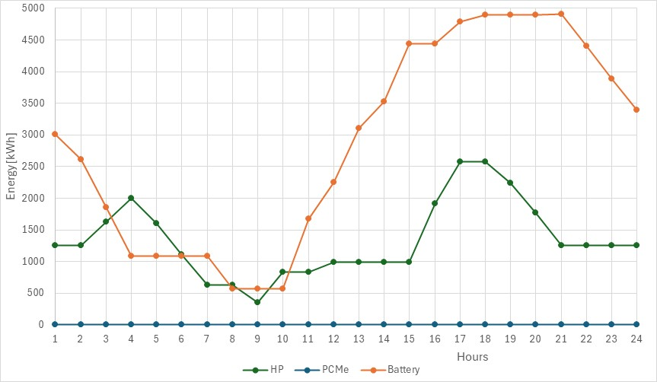

Fig. 1a; Economical Optimization



Table 1.a Economical Optimization scenario 1

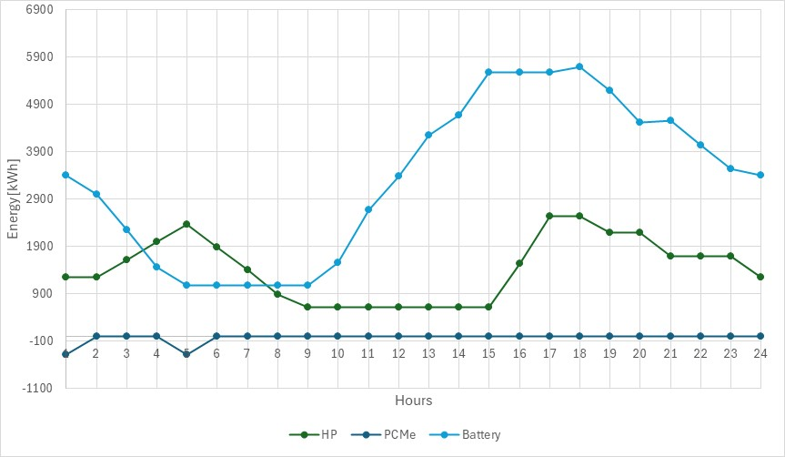

Fig. 1b;Self Consumtpion Optimization



Table 1. Self Consumtpion Optimization

Fig. 2a; Economical Optimization Scenario 2



Tab. 2a Economical Optimization Scenario 2

Fig. 2b;Self Consumtpion OptimizationScenatio 2



Tab 2b;Self Consumtpion OptimizationScenatio 2

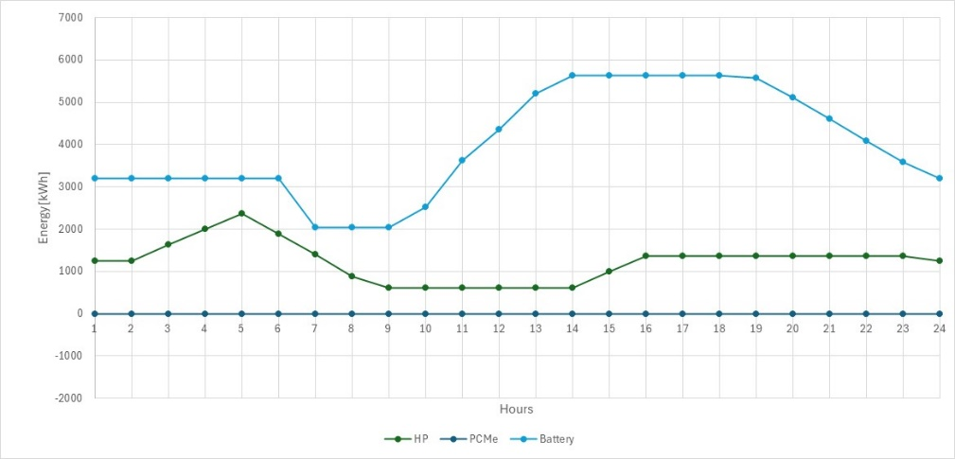

Fig. 3a; Economical Optimization Scenario 3



Tab. 3a; Economical Optimization Scenario 3

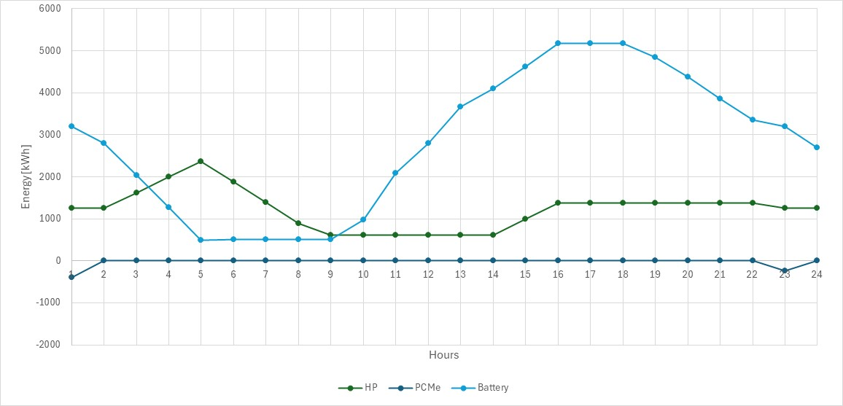

Fig. 3b;Self Consumtpion OptimizationScenatio 3



TAb. 3b;Self Consumtpion OptimizationScenatio 3

The evaluation of the reduction in CO2 emissions, since the system we are considering is similar to a fully renewable system, can only be assessed in terms of the amount of energy exchanged with thermal and electrical energy, through the evaluation of the emissive factor of the electrical and thermal grids.

The emissive factor related to the electrical and thermal grid refers to the amount of greenhouse gas emissions (mainly CO2) associated with the production and distribution of electrical and thermal energy through the grid, and it is equal to emission_factor_grid=0.354; //kgC02/kWh; emission_factor_ng=0.202; //kgCO2/kWh

|  |  |  |  |  |
| --- | --- | --- | --- | --- |
|  | Economic optimization |  | Self consumption scheme |  |
| Traditional system | 11715 |  | 6386 |  |
| Scenario base 1 | 6428 | -45,13% | 4264 | -33,2% |
| Scenario base 2 | 9646 | -17,66% | 6243,3 | -2,23% |
| Scenario Base 3 | 7572 | -35,36% | 8155 | 27,70% |

The reported results remain unchanged in the case of the Upper Cost scenario, while they change in the case of the Low-Cost scenario, making the PCM technology more competitive. It can therefore be inferred that the reduction in costs related to the technology and/or the increase in fuel prices can effectively impact the choice of the optimal strategy to be implemented.